**OLA PROJECT SQL QUIRES**

1. Retrieve all successful bookings:

create view successful_booking as

select * from bookings

where booking_status = 'Success';

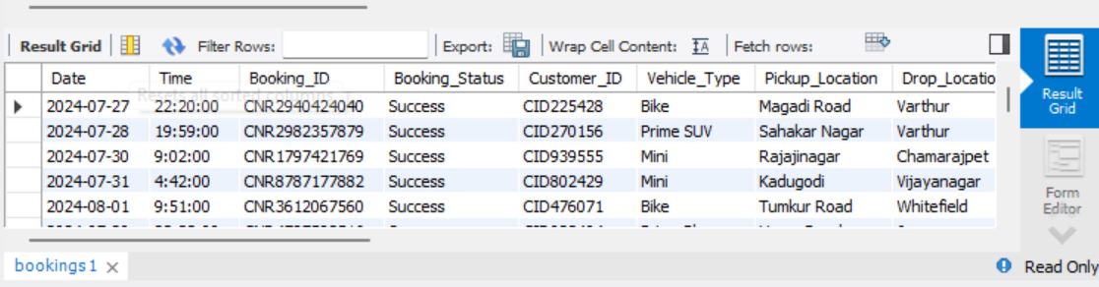

2. Find the average ride distance for each vehicle type:

create view ride_distance_for_each_vehicle as

select Vehicle_Type,avg(ride_distance) as avg_distance

from bookings

group by Vehicle_Type;

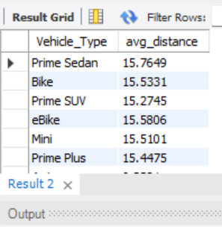

3. Get the total number of cancelled rides by customers:

create view cancelled_rides_by_customers as

select count(*) from bookings

where Booking_Status = 'Canceled by Customer';

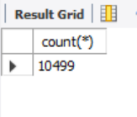

4. List the top 5 customers who booked the highest number of rides

create view top_5_customers as

select Customer_ID, count(Booking_ID) as total_rides

from bookings

group by Customer_ID

order by total_rides desc

limit 5;

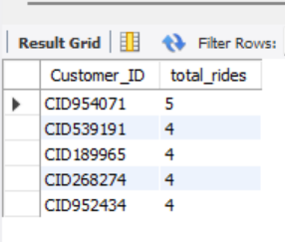

5. Get the number of rides cancelled by drivers due to personal and car-related issues:

create view cancelled_by_drivers_PC_ISSUES as

select count(*) from bookings

where Canceled_Rides_by_Driver = 'Personal & Car related issue';

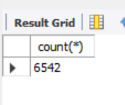

6. Find the maximum and minimum driver ratings for Prime Sedan bookings:

create view driver_rating_for_prime_sedan as

select Vehicle_Type, max(Driver_Ratings) as max_rating, min(Driver_Ratings) as min_ratings

from bookings

where Vehicle_Type = 'Prime Sedan';

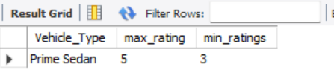

7. Retrieve all rides where payment was made using UPI:

create view upi as

select * from bookings

where Payment_Method = 'UPI';

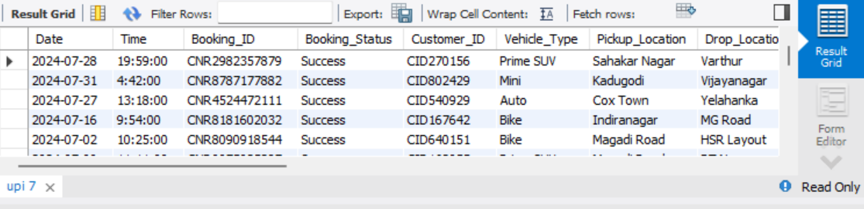

8. Find the average customer rating per vehicle type:

create view average_customer_rating_per_vehicle_type as

select Vehicle_Type,avg(Customer_Rating) from

bookings

group by Vehicle_Type;

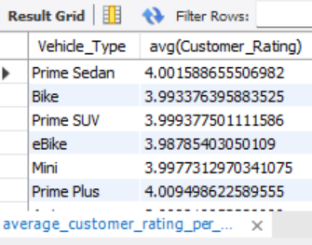

9. Calculate the total booking value of rides completed successfully:

create view booking_value_of_rides_completed_successfully as

select sum(Booking_Value), Booking_Status from bookings

where Booking_Status = 'Success';

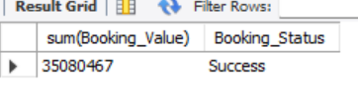

10. List all incomplete rides along with the reason

create view incomplete_reason as

select Incomplete_Rides, Incomplete_Rides_Reason

from bookings

where Incomplete_Rides = 'yes';

